Technical Datasheet of RS485 over MQTT Through WIFI

Product Overview: -

WIN-GW-RS485-WIFI -MQTT is an industrial-grade RS-485 to MQTT and Modbus-TCP converter (optional), designed to bridge legacy serial devices with modern IoT and Ethernet networks. Featuring a built-in Web UI, it allows easy configuration of RS-485 communication parameters, MQTT settings, and Modbus-TCP settings. This compact and rugged device ensures reliable data transmission from serial devices to cloud platforms using the lightweight and secure MQTT protocol, while also supporting Modbus communication over TCP/IP for seamless integration with existing industrial networks.

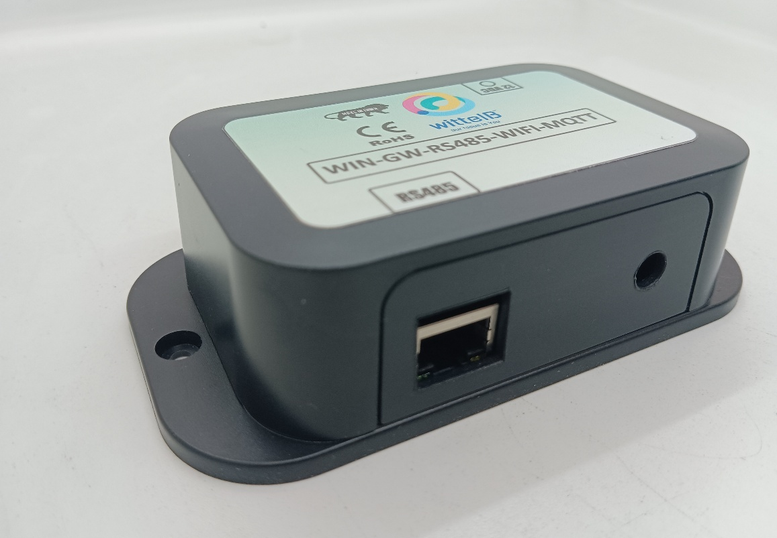

Key Features:
- RS485 Serial Interface
Supports long-distance serial communication (up to 1200 meters) with industrial devices.
- MQTT Protocol Support
Publishes RS485 data directly to MQTT brokers (supports custom topics and payloads).
- WIFI Connectivity
Device need local WIFI to publish the data to cloud using that network.
- Modbus – TCP Support (optional)
Enables integration of legacy Modbus serial devices over TCP/IP networks.
- Web-Based Configuration
Intuitive Web UI for setting RS485 parameters, MQTT broker details, and WIFI network settings.
- Flexible MQTT Settings
Configure topics, QoS levels, authentication, and more.
- Real-Time Data Publishing
Ensures low-latency communication to cloud dashboards or local servers.
- Compact & Industrial-Grade Design
Suitable for deployment in harsh environments.

Advantage
- Reliable Ethernet Connectivity
- Provides stable and high-speed data transfer for industrial environments.
- Low-Latency Data Publishing
- Real-time data delivery ensures accurate and timely monitoring.
- Customizable MQTT Topics and Payloads
- Supports flexible MQTT topic structures and data formatting for cloud dashboards and APIs.
- Supports Legacy Serial Devices
- Allows older RS485-based equipment to communicate with modern cloud applications.

Specifications

- I/O Connectors: 2 Pin 5.08 mm pitch pluggable screw terminals.
- Dimensions : 70 mm L x 110 mm B x 50 mm H
- Power: Input Power–12v to 24v AC/DC, typical power consumption-5W
- Operating Temperature: 0 – 60° C (32 ~ 140°F)
- Storage Temperature: -20 - 70° C (-4 ~ 158°F)
- Storage Humidity : 5 ~ 95 % RH, non – Condensing


- Certifications

Additional Features: -

- Communication Port isolated Input power reverse polarity safety
- ESD Safety IEC 61000-4-2, ± 30KV contact, ± 30KV air
- EFT IEC 61000-4-4, 50A (5/50ms) 750V isolation.
- CRC Error check.

Configuration Settings: -

- Connect a 24V AC/DC power supply to the module.
- Connect one or more RS485 slave devices to the module’s A & B terminals.
- Then Access the module's configuration hotspot and enter the IP:192.168.4.254 to configure the module
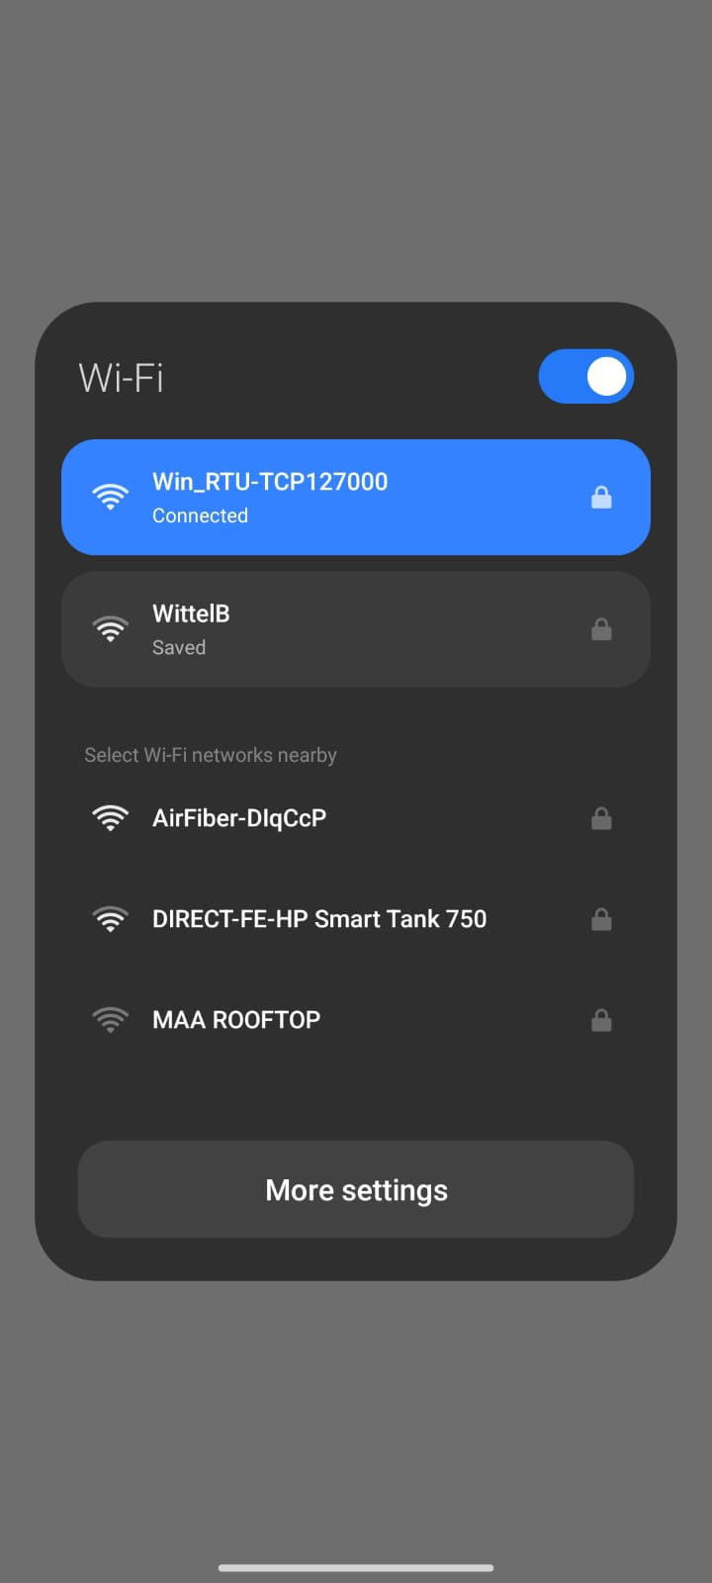
(ID: Win_RTU-TCPXXXXXX, PASS: 12345678).
RTU-WIFI Configuration For Modbus TCP (optional): -
- Enter the default IP For Modbus-TCP as:- 192.168.4.254
- Then RTU to WIFI Main Web interface will open as shown below

Page 1(optional)

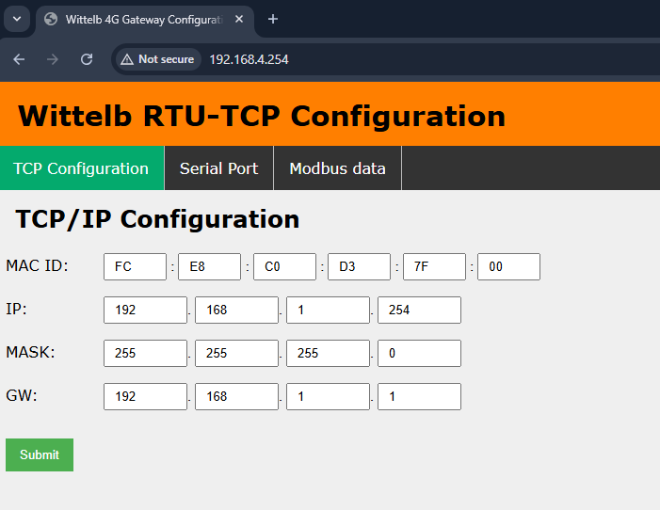
- Open the Network Configuration page.
- Enter the MAC ID in the designated field.
- Enter the IP address, Subnet Mask, and Gateway in the respective fields.
- Click the Submit button to save the TCP/IP configuration.
- Upon successful submission of the TCP/IP configuration, the module initializes the current input
- Socket and starts data communication over the TCP/IP network.
- Before starting communication, ensure that the slave devices’ serial communication parameters (such as baud rate and data bits) match the master configuration. If they differ, use the Serial Communication settings button to adjust them. For more details, refer to Page 2.

Page 2

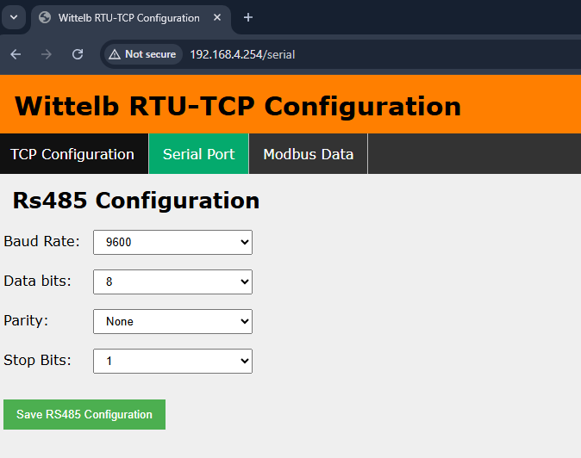

- Enter the Baud Rate, Data Bits, Parity, and Stop Bits according to your communication settings.
- Here you can configure the serial communication parameters for the slave device you are setting up.

Page 3

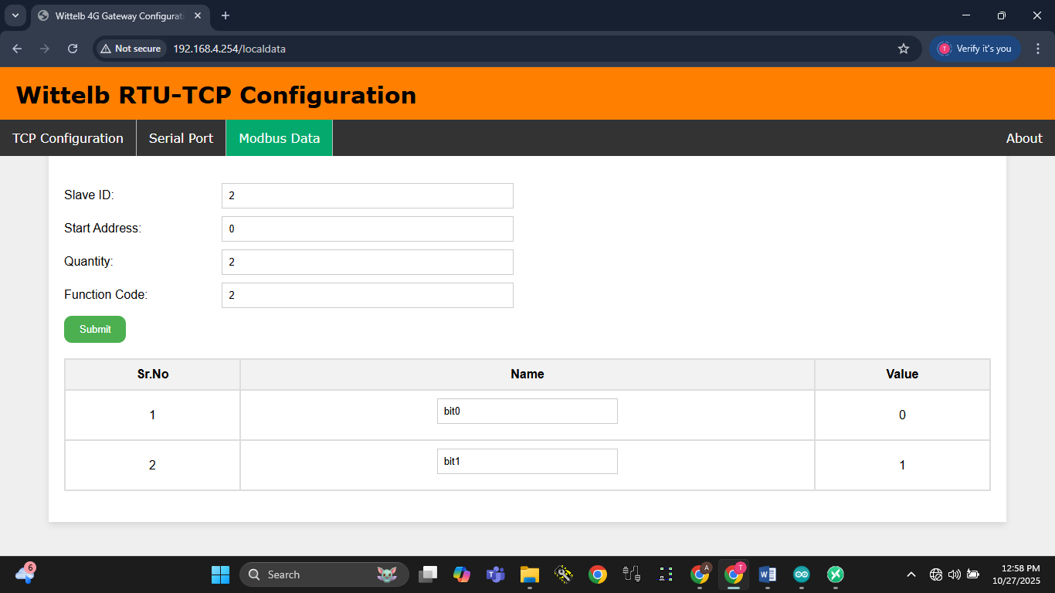

- Enter the Slave ID, Start Address (register), Quantity (registers), and Function Code, according to your Slave settings Then Submit.
- Based on the slave configuration, enter the required details and submit them.
- Then the holding registers will display the data from the connected slave devices.
- Once submitted, the slave data will be published to the MQTT broker.

RTU-WIFI Configuration For MQTT: -
- Enter the default IP For MQTT Configuration as:- 192.168.4.254/mqtt
- Then RTU to WIFI MQTT Web interface will open as shown below

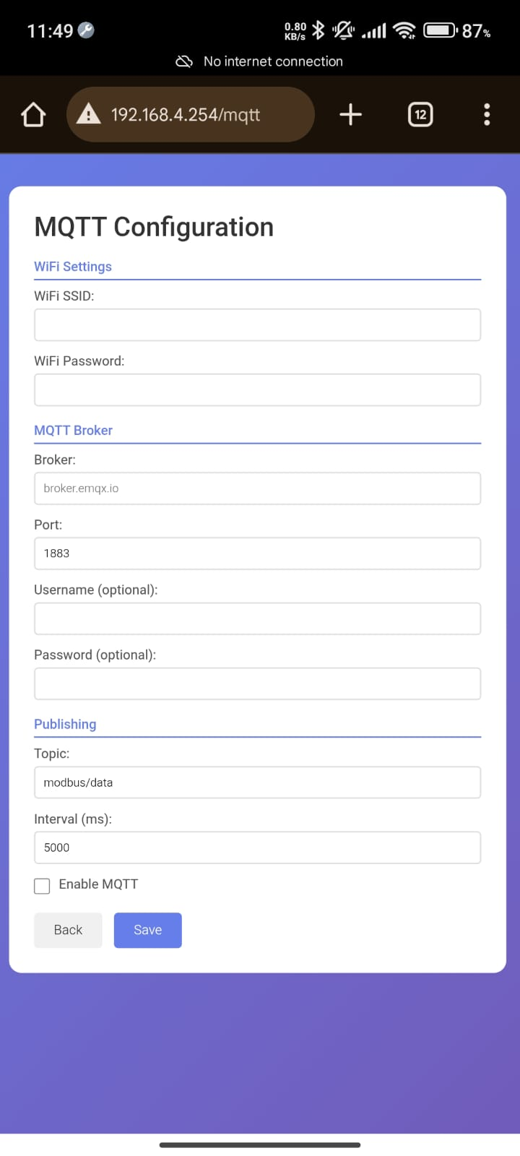
- Then enter the local Wi-Fi SSID and Wi-Fi password, which are required for the device to connect to that local Wi-Fi network and send data to the cloud via MQTT using the same WIFI network.
- For MQTT Broker:- Enter Broker ID, Port, Username/Password(optional), Topic(to get data in mqtt), Time interval(in milisec) ex: for 5 sec (5000) for 10sec(10000)
- Then click Enable MQTT box and Save
- After clicking on save configuration you will get data on desired Topic.
- Then it will redirect to the Default Modbus Web interface 192.168.4.254

Get Data on MQTT:-

- To get the slaves data on MQTT Refer Page 3 and enter the connected slave details and submit one by one.
- Once submitted you will get the slaves data in MQTT Broker on the subscribed topic
- This is an example of a module sending data to a public broker. Similarly, you can configure your cloud details on the device to send data to your cloud server, which can then be used to create a dashboard for monitoring.
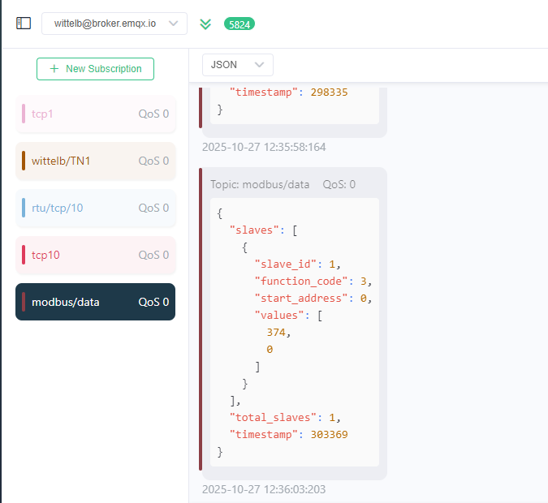

Contact us: -
Augmatic Technologies Pvt. Ltd.,
Plot no 6, Shah Industrial Estate II,
Kotambi, Vadodara – 391510.
Vadodara – 391510.
Email – Sales@wittelb.com

